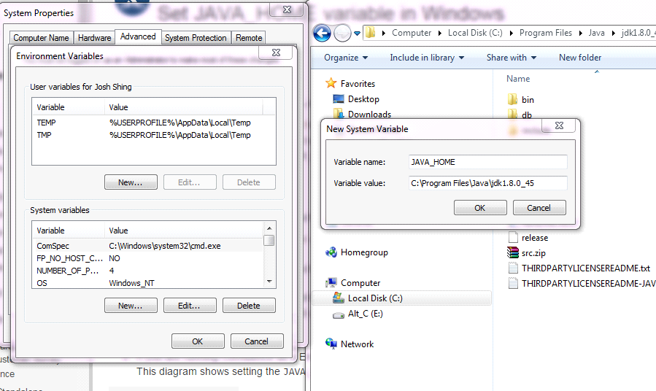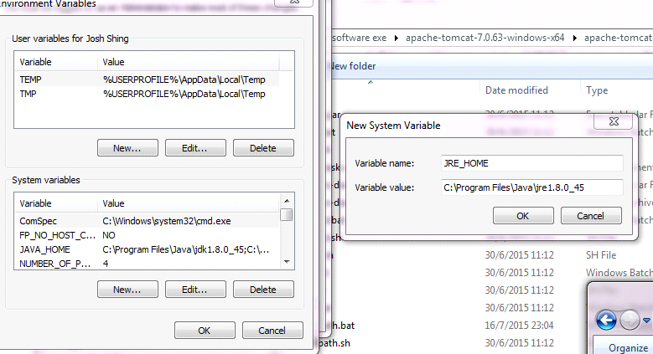

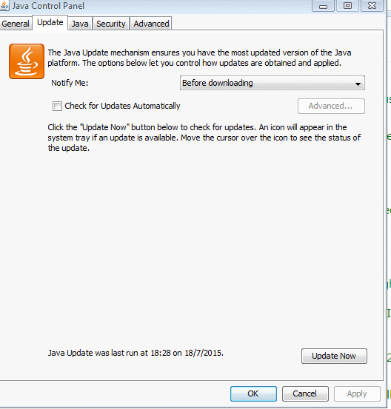

只要在setclasspath.bat的開頭聲明環境變量，如我的就是：   
  
rem ------------------------------------------------- --------------------------   
rem Set CLASSPATH and Java options   
rem   
rem $Id: setclasspath.bat 505241 2007-02-09 10:22:58Z jfclere $   
rem ------------------------------------------------- --------------------------   
  
set JAVA_HOME=C:\Program Files\Java\jdk1.7.0_45  
set JRE_HOME=C:\Program Files\Java\jre7  
  
rem Make sure prerequisite environment variables are set   
if not "%JAVA_HOME%" == "" goto gotJdkHome   
if not "%JRE_HOME%" == "" goto gotJreHome   
echo Neither the JAVA_HOME nor the JRE_HOME environment variable is defined   
echo At least one of these environment variable is needed to run this program   
goto exit

--------------------------------------------

tomcat-users.xml

<role rolename="tomcat"/>

<user username="admin" password="admin" roles="admin-gui, manager-gui, manager-script"/>

RUN TOMCAT SERVER

catalina.bat run

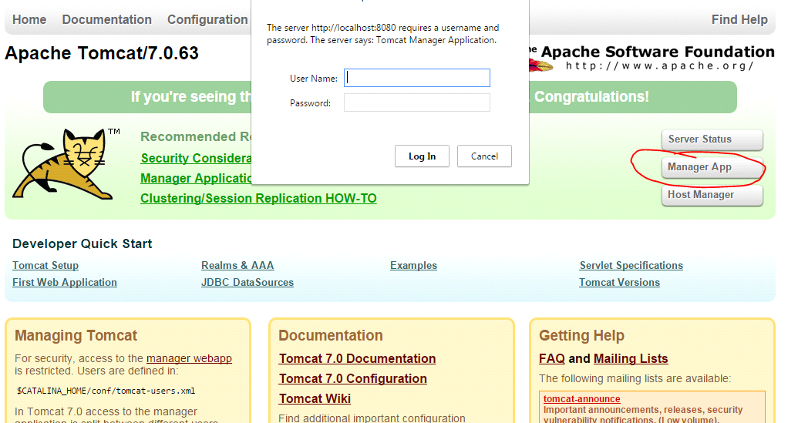

The configuration file is apache-tomcat-7.0.63\webapps\manager\WEB-INF\web.xml.  
In the file, look for the code snippet that says:

***<multipart-config>***

***<!-- 50MB max -->***

***<max-file-size>52428800</max-file-size>***

***<max-request-size>52428800</max-request-size>***

***<file-size-threshold>0</file-size-threshold>***

***</multipart-config>***

--------------------------------------------------------------------------------------

Edit tomcat/conf/server.xml.

Specify a bind address for that connector:

<Connector

port="8080"

protocol="HTTP/1.1"

address="127.0.0.1"

connectionTimeout="20000"

redirectPort="8443"

/>

Help -> Install New Software

Choose "Helios - <http://download.eclipse.org/releases/helios>" site

Expand "Web, XML, and Java EE Development"

Eclipse Java EE Developer Tools

Eclipse Java Web Developer Tools

Eclipse Web Developer Tools

Eclipse XML Editors and Tools

JST Server Adapters

JST Server Adapters Extentions

Dali Java Persistence Tools - EclipseLink JPA Support

Eclipse Faceted Project Framework

Eclipse Faceted Project Framework JDT Enablement

JST Server Adapters

JST Server Adapters Extensions

JST Server UI

WST Server Adapters

Subversive

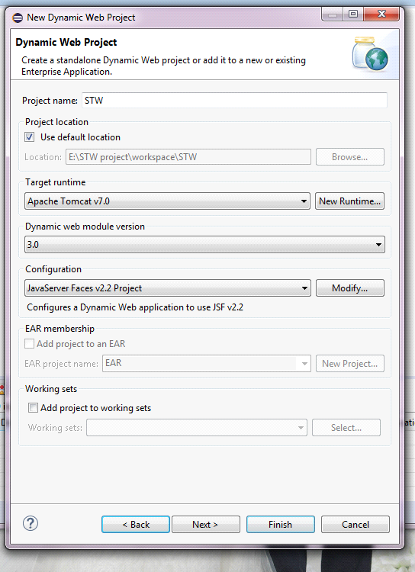

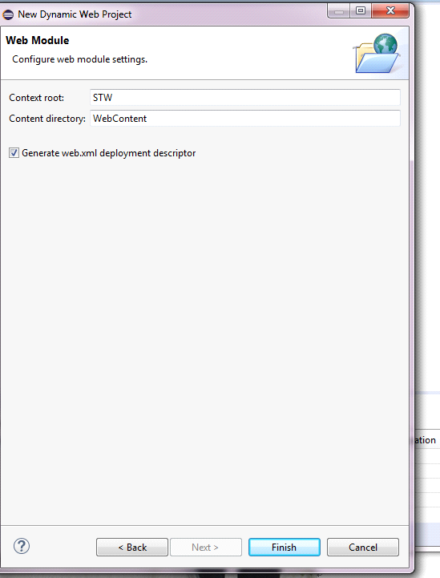

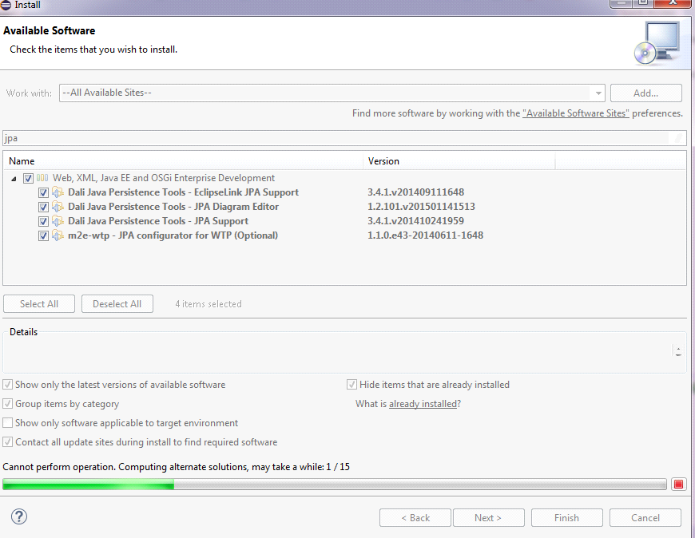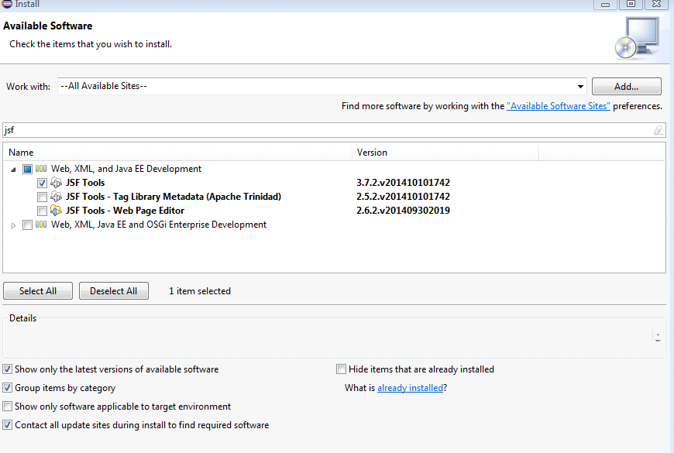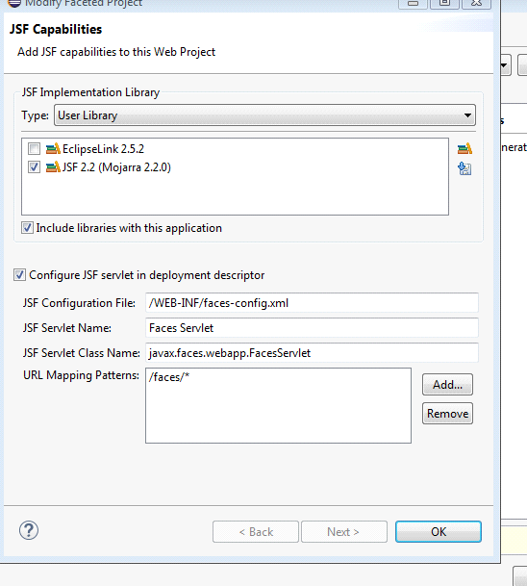.

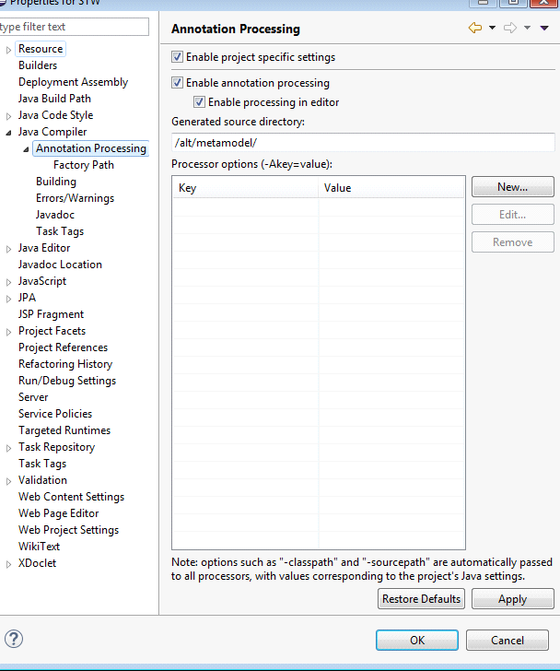

/jpaMetaModel/

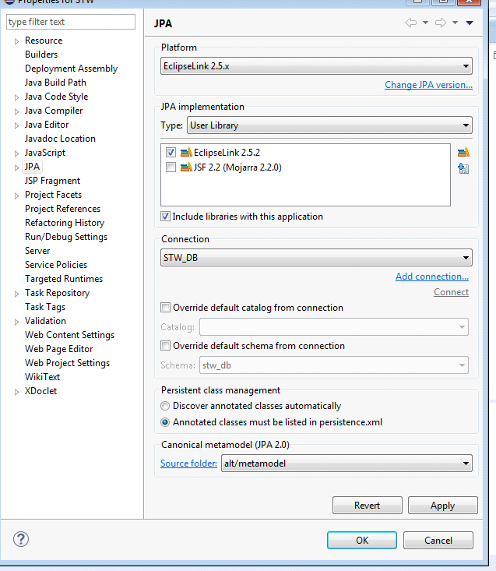

mysql -h localhost -u root -p

mySQL

pw: Abcd1234

port: 1532

acc.

user: admin

pw: admin

select user();

select host, user, password from mysql.user;

show databases;

CREATE DATABASE stw_db;

USE stw_db;

SHOW tables;

drop table stw_db.C_USER;

CREATE TABLE stw_db.C_USER

(

ID_CODE varchar(30) NOT NULL,

PW_CODE varchar(16),

LAST_NAME varchar(255),

FIRST_NAME varchar(255),

TEL_NO int,

PRIMARY KEY (ID_CODE)

);

ALTER TABLE stw_db.C_USER

ADD PRIMARY KEY (ID_CODE);

INSERT INTO stw_db.C_USER (ID_CODE, PW_CODE, LAST_NAME, FIRST_NAME, TEL_NO)

VALUES ('admin1002','!q2w3e4r','Dog','Leung','23456789');

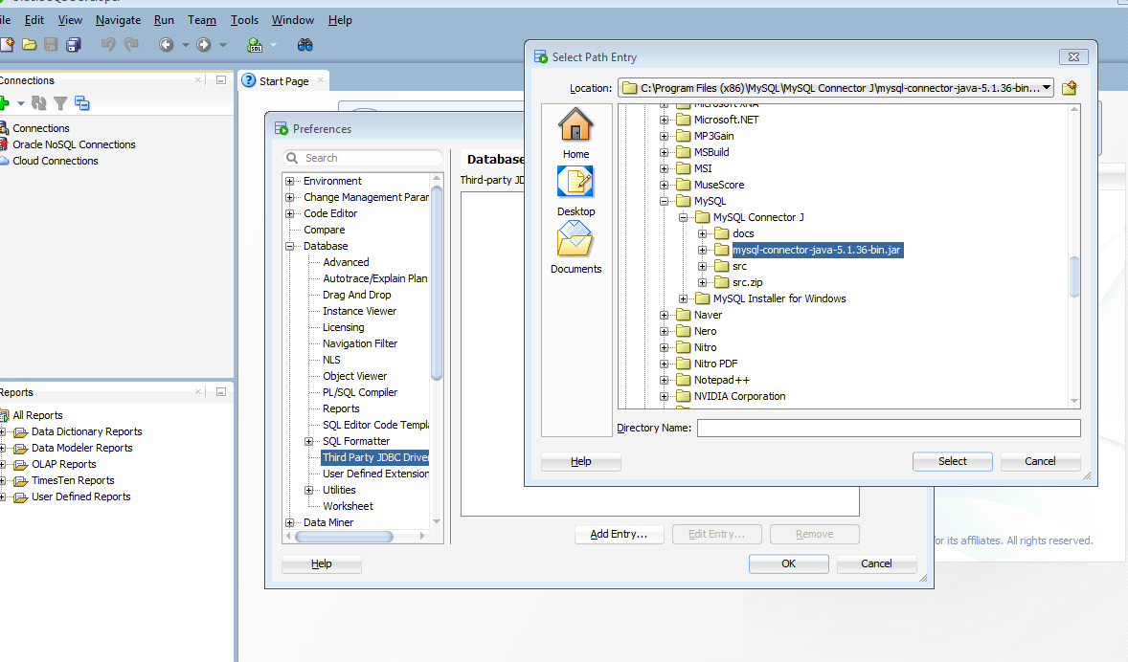

Subversion

admin account name: admin

All account pw: !q2w3e4r

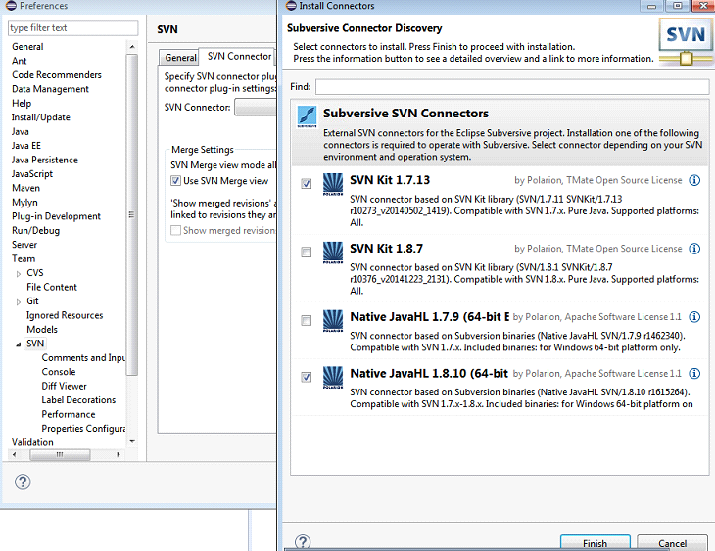

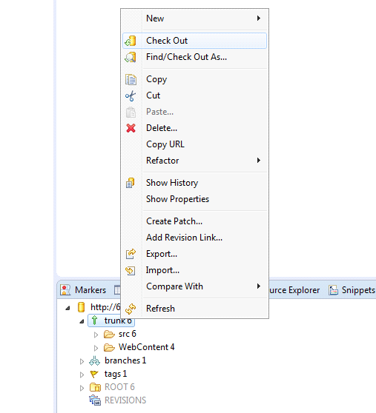

Right Click the “trunk” and select “Check Out”

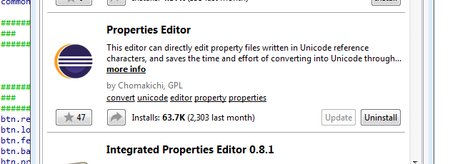

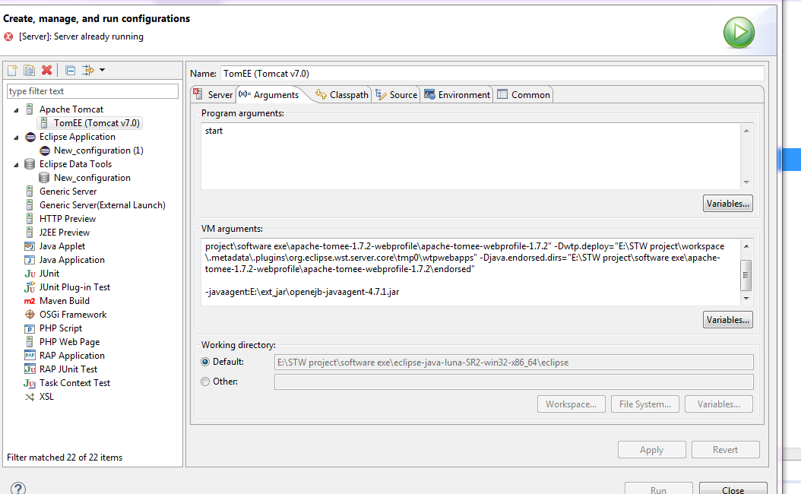

copy

**mysql-connector-java-5.1.36-bin.jar**

**jsf-api-2.2.9.jar**

**jsf-impl-2.2.9.jar**

**spring-instrument-tomcat-4.0.6.RELEASE.jar**

to E:\STW project\software exe\apache-tomee-1.7.2-webprofile\apache-tomee-webprofile-1.7.2\lib